###### A Project report on

**IMAGE COLOURIZATION USING MACHINE LEARNING WITH PYTHON**

A Dissertation submitted in partial fulfillment of the academic requirements for the award of the degree.

**Bachelor of Technology**

**In**

**Computer Science & Engineering**

Submitted by

KOKKONDA RAJANI 19H51A05G7

MADALA NAVYA 19H51A05H2

ANUGAM YUVARAJU 19H51A05J5

Under the esteemed guidance of Dr G Ravi Kumar Associate Professor



##### Department of Computer Science and Engineering

**CMR College of Engineering & Technology**

(An Autonomous Institution under UGC & JNTUH, Approved by AICTE, Permanently Affiliated to JNTUH, Accredited by NBA.)

#### 2019- 2023

###### A Project report on

**IMAGE COLOURIZATION USING MACHINE LEARNING WITH PYTHON**

A Dissertation submitted to JNTU Hyderabad in partial fulfillment of the academic requirements for the award of the degree.

**Bachelor of Technology**

**in**

**Computer Science and Engineering**

Submitted by

KOKKONDA RAJANI 19H51A05G7

MADALA NAVYA 19H51A05H2

ANUGAM YUVARAJU 19H51A05J5

Under the esteemed guidance of

Dr G Ravi Kumar

Associate Professor



**Department of Computer Science and Engineering**

**CMR COLLEGE OF ENGINEERING & TECHNOLOGY**

(An Autonomous Institution under UGC & JNTUH, Approved by AICTE, Permanently Affiliated to JNTUH, Accredited by NBA.)

KANDLAKOYA, MEDCHAL ROAD, HYDERABAD - 501401.

#### 2019- 2023

**CMR COLLEGE OF ENGINEERING & TECHNOLOGY**

KANDLAKOYA, MEDCHAL ROAD, HYDERABAD – 501401

DEPARTMENT OF COMPUTER SCIENCE AND ENGINEERING



**CERTIFICATE**

This is to certify that the Mini Project-2 report entitled **"Image colourization using machine learning with python"** being submitted by K.Rajani(19H51A05G7), M.Navya(19H51A05H2), A.Yuvaraju(19H51A05J5) in partial fulfillment for the award of **Bachelor of Technology in Computer Science and Engineering** is a record of bonafide work carried out his/her under my guidance and supervision.

The results embody in this project report have not been submitted to any other University or Institute for the award of any Degree.

**Dr G Ravi Kumar**

**Associate Professor**

**Dept. of CSE**

**Dr S Siva Skandha Associate Professor and HOD Dept. of CSE**

Acknowledgement

With great pleasure I want to take this opportunity to express my heartfelt gratitude to all the people who helped in making this project work a grand success.

I am grateful to Mr. G Ravi Kumar, Associate Professor, Dept of Computer Science and Engineering for his valuable suggestions and guidance during the execution of this project work.

I would like to thank Dr. S Siva Skandha, Head of the Department of Computer Science and Engineering, for his moral support throughout the period of my study in CMRCET.

I am highly indebted to Dr. V A Narayana, Principal CMRCET for giving permission to carry out this project in a successful and fruitful way.

I would like to thank the Teaching & Non- teaching staff of Department of Computer Science and Engineering for their co-operation

Finally I express my sincere thanks to Mr. Ch. Gopal Reddy, Secretary, CMR Group of Institutions, for his continuous care. I sincerely acknowledge and thank all those who gave support directly and indirectly in completion of this project work.

**Student Roll no**

19H51A05G7

19H51A05H2

19H51A05J5

**TABLE OF CONTENTS**

|  |  |  |  |
| --- | --- | --- | --- |
| **CHAPTER** | **TITLE** | | **PAGE** |
| **NO.** | **NO.** |
|  | **LIST OF FIGURES** | | ii |
|  | **LIST OF DIAGRAMS** | | iii |
|  | **ABSTRACT** | | iv |
| **1** | **INTRODUCTION** | | 1 |
|  | 1.1 | Aim | 2 |
|  | 1.2 | Scope & Limitations | 2 |
|  |  | 1.2.1 Scope | 2 |
|  |  | 1.2.2 Limitations | 2 |
| **2** | **BACKGROUND WORK** | | 3 |
|  | 2.1 | Introduction | 4 |
|  | 2.2 | Existing solutions | 4-5 |
| **3** | **PROPOSED SYSTEM** | | 6 |
|  | 3.1 | Introduction | 7 |
|  | 3.2 | System design | 7 |
|  | 3.3 | Requirement Analysis | 8 |
|  |  | 3.3.1 Hardware Requirements | 8 |
|  |  | 3.3.2 Software Requirements | 8 |
|  | 3.4 | Advantages | 9 |
| **4** | **DESIGNING** | | 10 |
|  | 4.1 | Preliminary Design | 11 |
|  |  | 4.1.1 Flow chart | 11 |
|  |  | 4.1.2 ER Diagrams | 12 |
| **5** | **RESULTS AND DISCUSSION** | | 13 |
|  | 5.1 | Implementation | 14 |
|  | 5.2 | Result | 17 |
| **6** | **CONCLUSION AND FUTUREWORK** | | 20 |
|  | 6.1 | Conclusion | 21 |
|  | 6.2 | Future Works | 22 |
| **7** | **REFERENCES** | | 23 |

**List of Figures**

|  |  |  |  |
| --- | --- | --- | --- |
|  | **CHAPTER** | **TITLE** | **PAGE** |
| **SNO.** | **NO.** | **NO.** |
| 1 | 1.1 | Colourization | 2 |
| 2 | 3.1 | Architecture | 7 |
| 3 | 5.1 | Library code | 14 |
| 4 | 5.2 | Colour transfer code | 14 |
| 5 | 5.3 | Image State code | 16 |
| 6 | 5.4 | Show Image code | 16 |
| 7 | 5.5 | Open Module | 17 |
| 8 | 5.6 | Code | 17 |
| 9 | 5.7 | Run Module | 18 |
| 10 | 5.8 | Console | 18 |
| 11 | 5.9 | Input image | 19 |
| 12 | 5.10 | Output image | 19 |



**List of Diagrams**

|  |  |  |  |
| --- | --- | --- | --- |
| **Diagram** | **CHAPTER** | **TITLE** | **PAGE** |
| **NO.** | **NO.** |
| **NO.** |
| 1 | 4.1.1 | Flow chart | 11 |
| 2 | 4.1.2 | Use case diagram | 12 |
| 3 | 4.1.2 | Sequence diagram | 12 |



**ABSTRACT**

We propose a method for colorizing photos, this is, providing a colour version of a given gray scale image. The method does not depend on human input, and is completely automatic. It does not depend on segmentation, scribbling or sophisticated image processing techniques.

We present a convolutional-neural-network-based system that faithfully colorizes black and white photographic images without direct human assistance. We explore various network architectures, objectives, color spaces, and problem formulations. The final classification-based model we build generates colorized images that are significantly more aesthetically-pleasing than those created by the baseline regression-based model, demonstrating the viability of our methodology and revealing promising avenues for future work



# CHAPTER 1

## INTRODUCTION



* 1. AIM

The aim of this project is to create an interface to convert black and white images to colorized images which are more aesthetically pleasing. To convert a black and white image to coloured without human inputs and to be completely automatic.

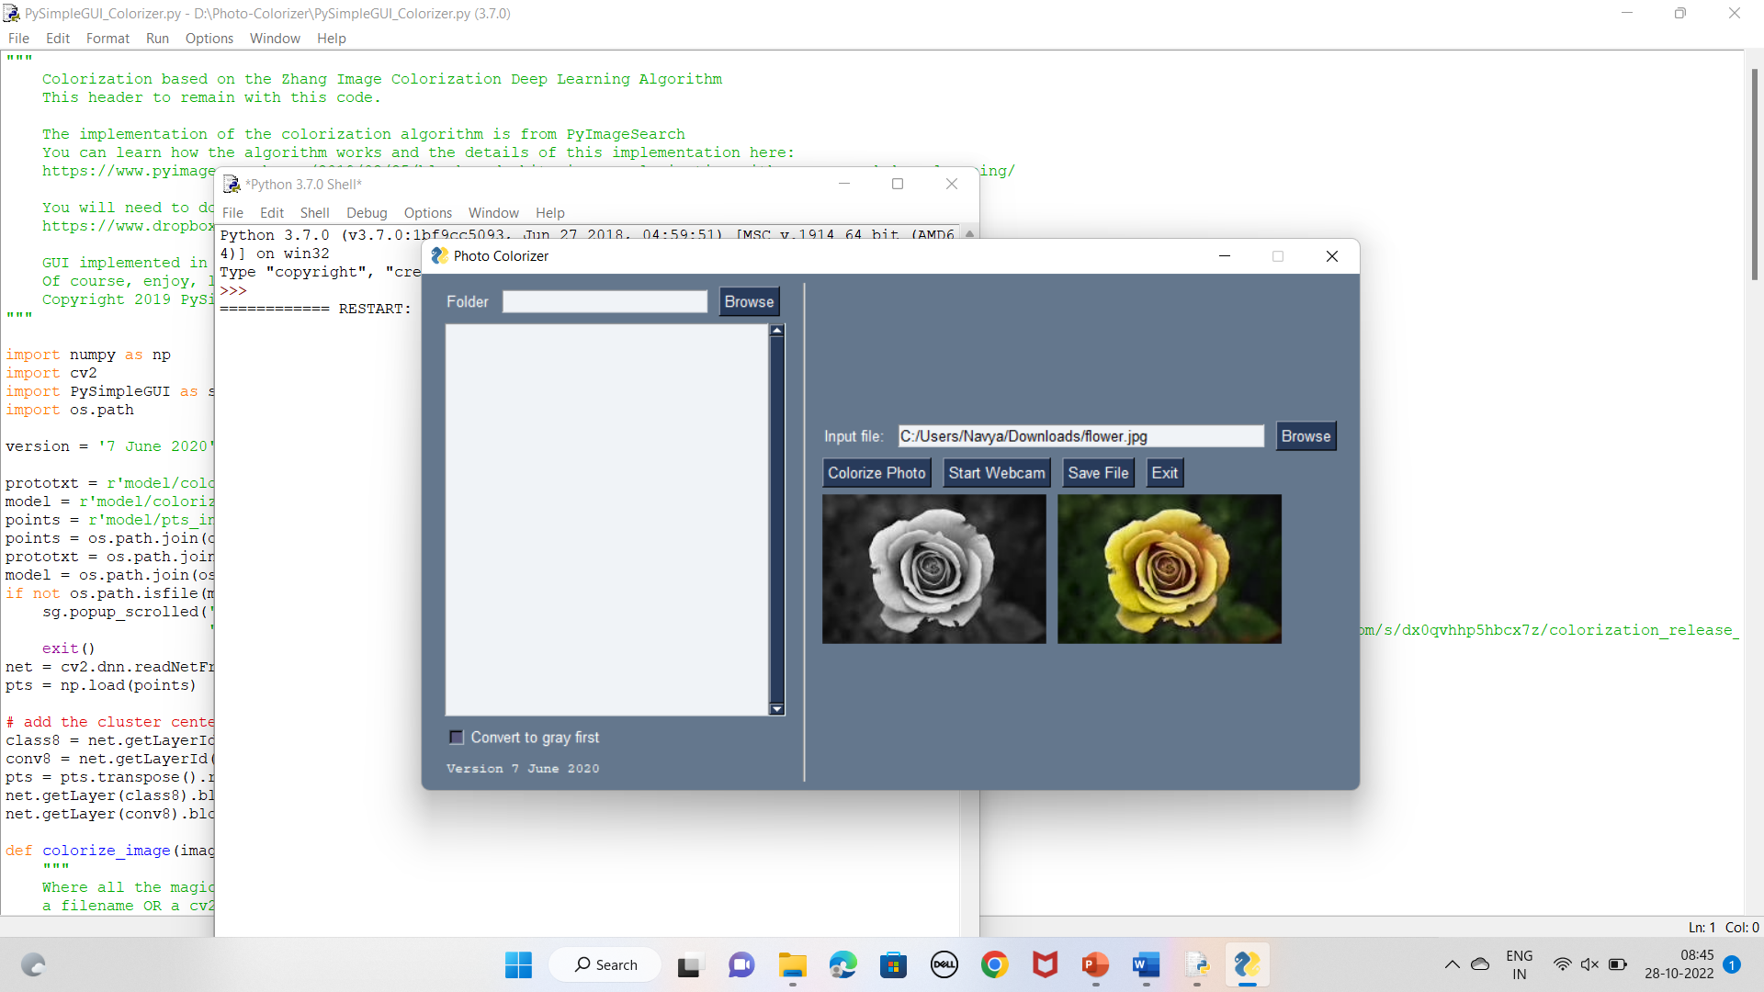

Figure 1.1-Colorization

* 1. SCOPE

There are many methods to colourize the photo using human inputs. Scribbling is the most known form of colouring a image. But the results were not satisfying to the end users. For image colourization to be automatic and to make it user friendly this project is useful.

This results will be more efficient than the traditional old methods.

1.2.2 LIMITATIONS

Cannot improve photo quality after colourization.

Do not have an option to colourize images from online i.e., images should be downloaded to the device to colour them.

# CHAPTER 2

## BACKGROUND WORK

CMRCET B. Tech (CSE) Page No 3

* 1. INTRODUCTION

Automated colorization of black and white images has been subject to much research within the computer vision and machine learning communities. Beyond simply being fascinating from an aesthetics and artificial intelligence perspective, such capability has broad practical applications ranging from video restoration to image enhancement for improved interpretability. Here, we take a statistical-learning-driven approach towards solving this problem. We design and build a convolutional neural network (CNN) that accepts a black-and-white image as an input and generates a colorized version of the image as its output. The system generates its output based solely on images it has “learned from” in the past, with no further human intervention. CNNs owe much of their success to their ability to learn and discern colors, patterns, and shapes within images and associate them with object classes. We believe that these characteristics naturally lend themselves well to colorizing images since object classes, patterns, and shapes generally correlate with color choice.

* 1. EXISTING SOLUTIONS

**Color transfer between images.**

We use a simple statistical analysis to impose one image's color characteristics on another. We can achieve color correction by choosing an appropriate source image and apply its characteristic to another image.

**Object re coloring based on intrinsic image estimation.**

Object recoloring is one of the most popular photo-editing tasks. The problem of object recoloring is highly under-constrained, and existing recoloring methods limit their application to objects lit by a white illuminant. Application of these methods to real-world scenes lit by colored illuminants, multiple illuminants, or interreflections, results in unrealistic recoloring of objects. In this paper, we focus on the recoloring of single-colored objects presegmented from their background. The single-color constraint allows us to fit a more comprehensive physical model to the object. We demonstrate that this permits us to perform realistic recoloring of objects lit by non-white illuminants, and multiple illuminants. Moreover, the model allows for more realistic handling of illuminant alteration of the scene. Recoloring results captured by uncalibrated cameras demonstrate that the proposed framework obtains realistic recoloring for complex natural images. Furthermore we use the model to transfer color between objects and show that the results are more realistic than existing color transfer methods.



**Automated colour grading using colour distribution transfer.**

This article proposes an original method for grading the colours between different images or shots. The first stage of the method is to find a one-to-one colour mapping that transfers the palette of an example target picture to the original picture. This is performed using an original and parameter free algorithm that is able to transform any N-dimensional probability density function into another one. The proposed algorithm is iterative, non-linear and has a low computational cost. Applying the colour mapping on the original picture allows reproducing the same ‘feel’ as the target picture, but can also increase the graininess of the original picture, especially if the colour dynamic of the two pictures is very different. The second stage of the method is to reduce this grain artefact through an efficient post-processing algorithm that intends to preserve the gradient field of the original picture.

**Palette based photo re coloring**

Image editing applications offer a wide array of tools for color manipulation. Some of these tools are easy to understand but offer a limited range of expressiveness. Other more powerful tools are time consuming for experts and inscrutable to novices. Researchers have described a variety of more sophisticated methods but these are typically not interactive, which is crucial for creative exploration. This paper introduces a simple, intuitive and interactive tool that allows non-experts to recolor an image by editing a color palette. This system is comprised of several components: a GUI that is easy to learn and understand, an efficient algorithm for creating a color palette from an image, and a novel color transfer algorithm that recolors the image based on a user-modified palette. We evaluate our approach via a user study, showing that it is faster and easier to use than two alternatives, and allows untrained users to achieve results comparable to those of experts using professional software.



# CHAPTER 3

## PROPOSED SYSTEM



* 1. INTRODUCTION

Existing colourizing methods adopt some description techniques to combine the information attained by evidence estimators. However, every description technique has its own limitations and drawbacks. Recently, CNNs have shown an explosive popularity in image classiﬁcation and other computer vision tasks. Traditional neural networks employ the original image in RGB channels as the input since it contains information about the picture such as color and structural features.

* 1. SYSTEM DESIGN
     1. **system architecture**

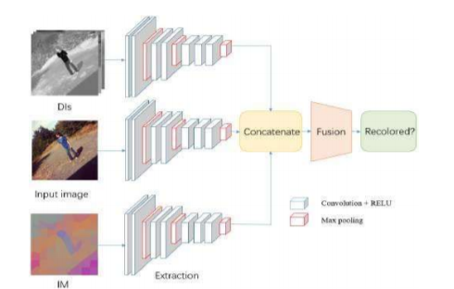

Figure 3.1 - Architecture



* 1. REQUIREMENT ANALYSIS

**3.3.1 HARDWARE REQUIREMENTS:**

* System : Pentium Dual Core.
* Hard Disk : 120 GB.
* Monitor : 15’’ LED
* Input Devices : Keyboard, Mouse
* Ram : 1 GB

**3.3.2 SOFTWARE REQUIREMENTS:**

* Operating system : Windows 10
* Coding Language : python
* Tool : PyCharm
* Database : MYSQL
* Server : Flask



* 1. ADVANTAGES

1. Image Recoloring

2. Graphical Representation and a feature fusion module



# CHAPTER 4

## DESIGNING



* 1. PRELIMINARY DESIGN

which assist in preliminary design process, are Flow Chart and ER diagrams.

4.1.1Flow Chart

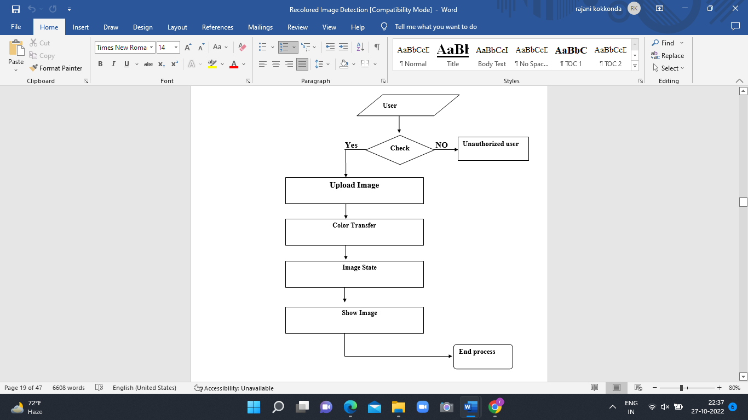

Figure 4.1-Flow chart



**4.1.2 UML Diagram**



Figure 4.2 – Use case diagram



Figure 4.3 – Sequence diagram



# CHAPTER 5

## RESULTS AND DISCUSSION



* 1. IMPLEMENTATION

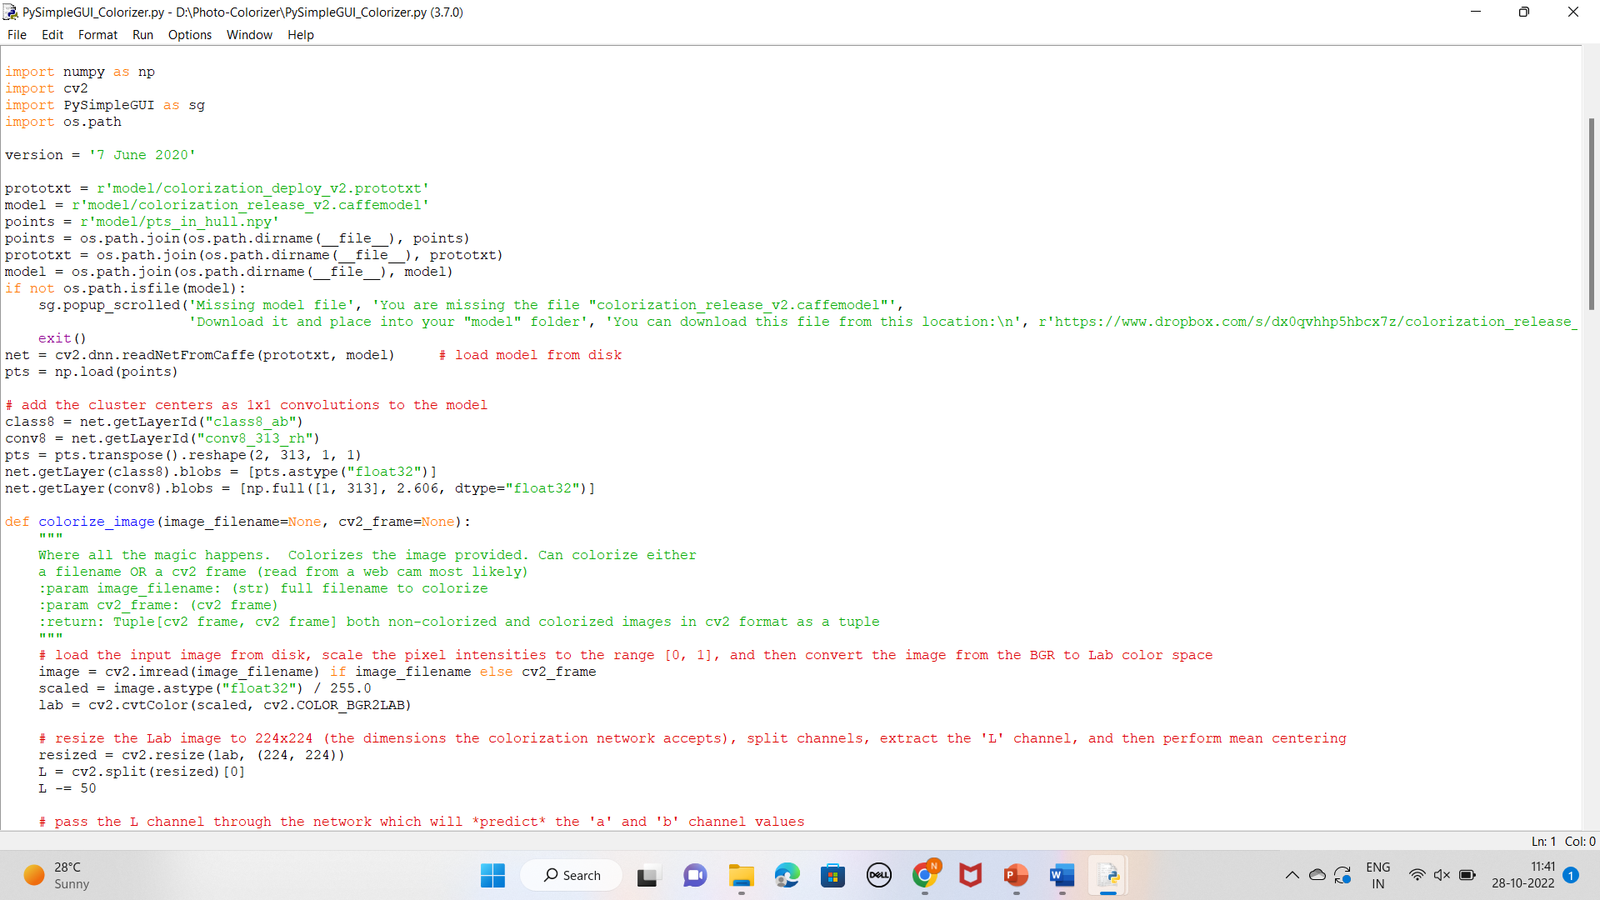

Figure 5.1 – Importing library Code

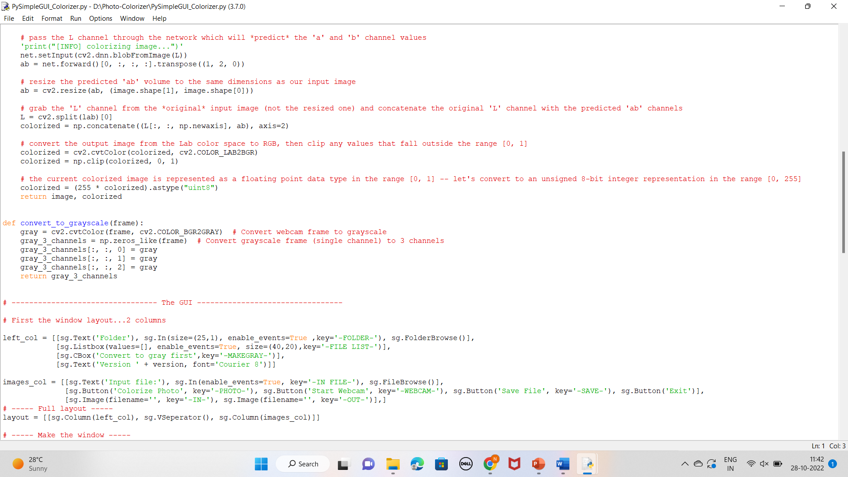

Figure 5.2 – Colour transfer code



**5.1.1MODULES:**

* Upload Image
* Color Transfer
* Image State
* Show Image

**MODULES DESCRIPTION:**

**1.Upload Image**

In this module Images upload here.

**2.Color Transfer**

In this module image which is upload change color. Image is transfer into recolored Image.

**3.ImageState**

In this module state of image is defined.

**4.ShowImage**

In this module recolored image is shown.

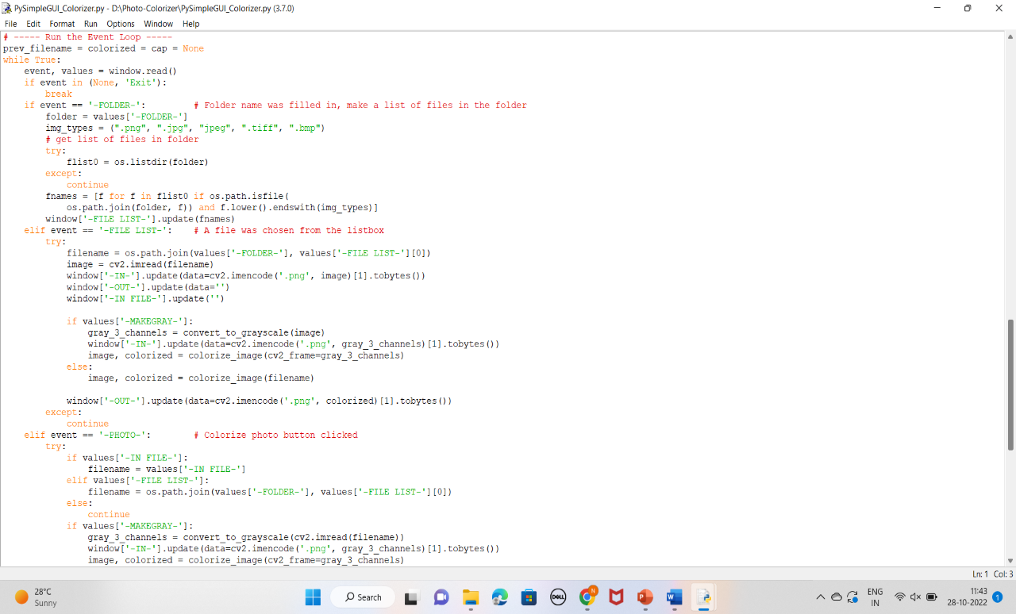

Figure 5.3 – ImageState code

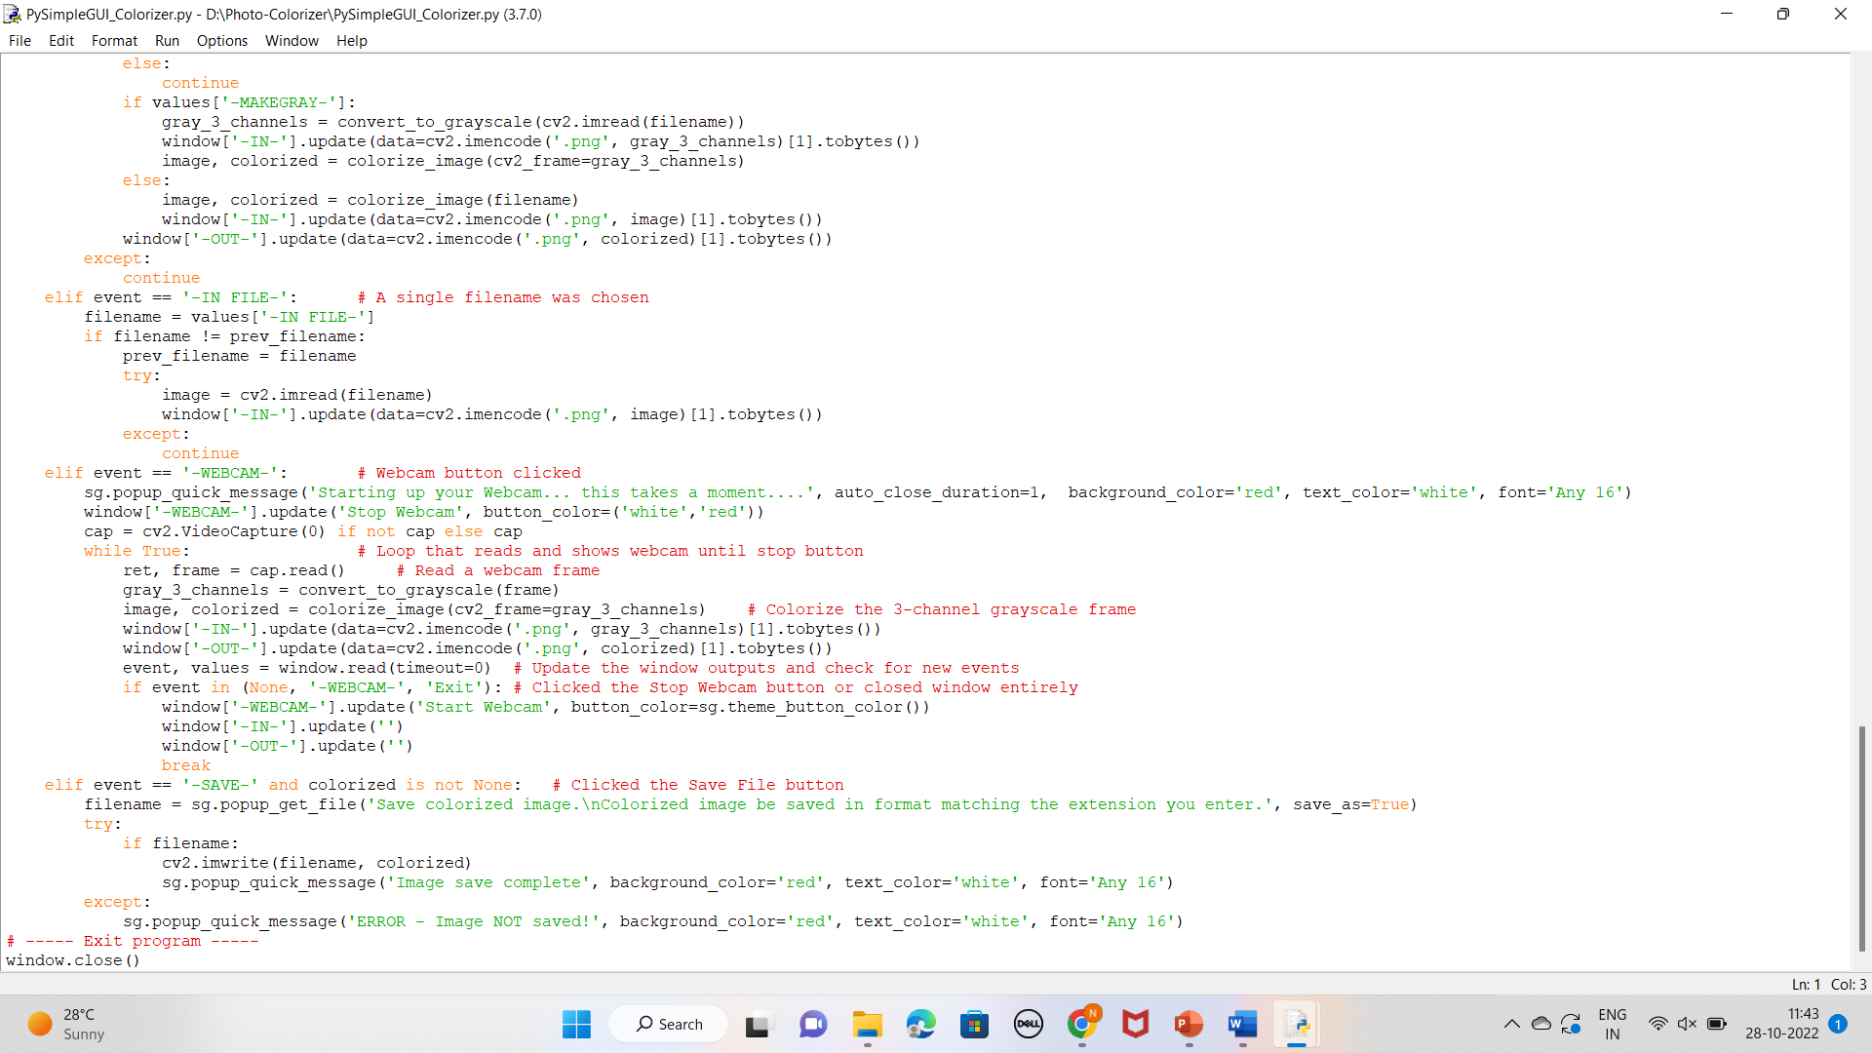

Figure 5.4 – ShowImage code

* 1. **RESULT**

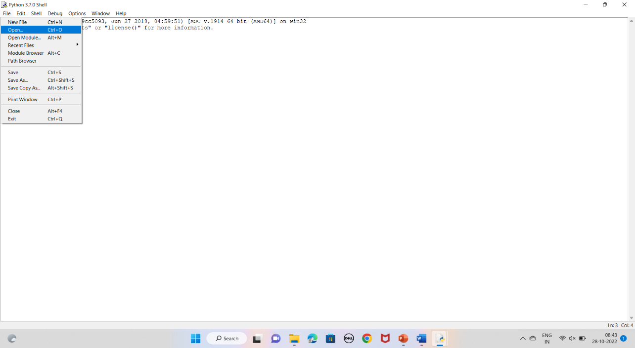

Figure 5.5 – Opening Module

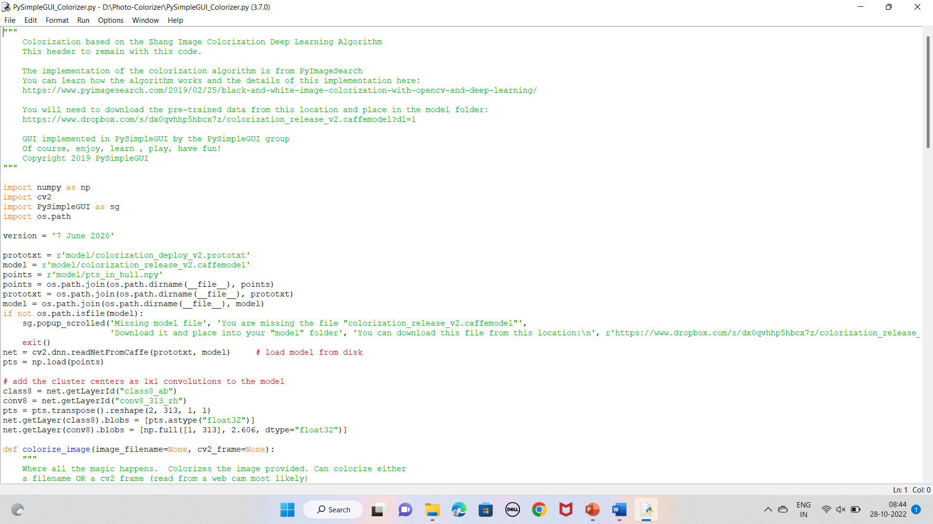

Figure 5.6 - Code

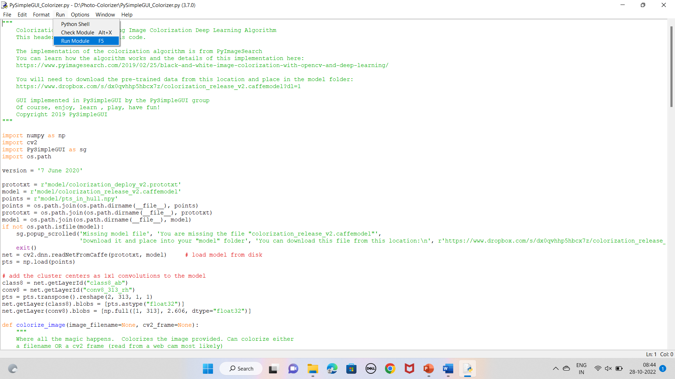

Figure 5.7 – Run Module

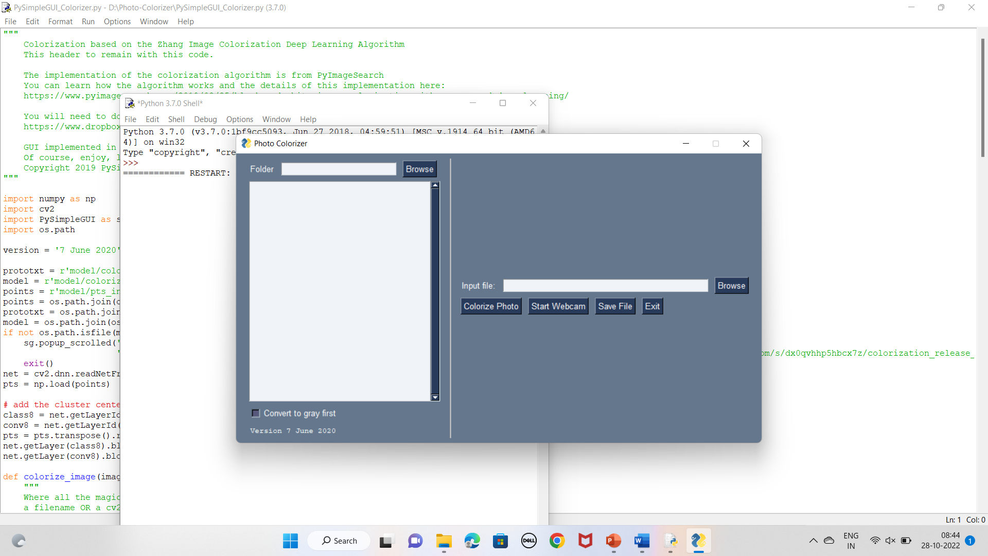

Figure 5.8 - Console

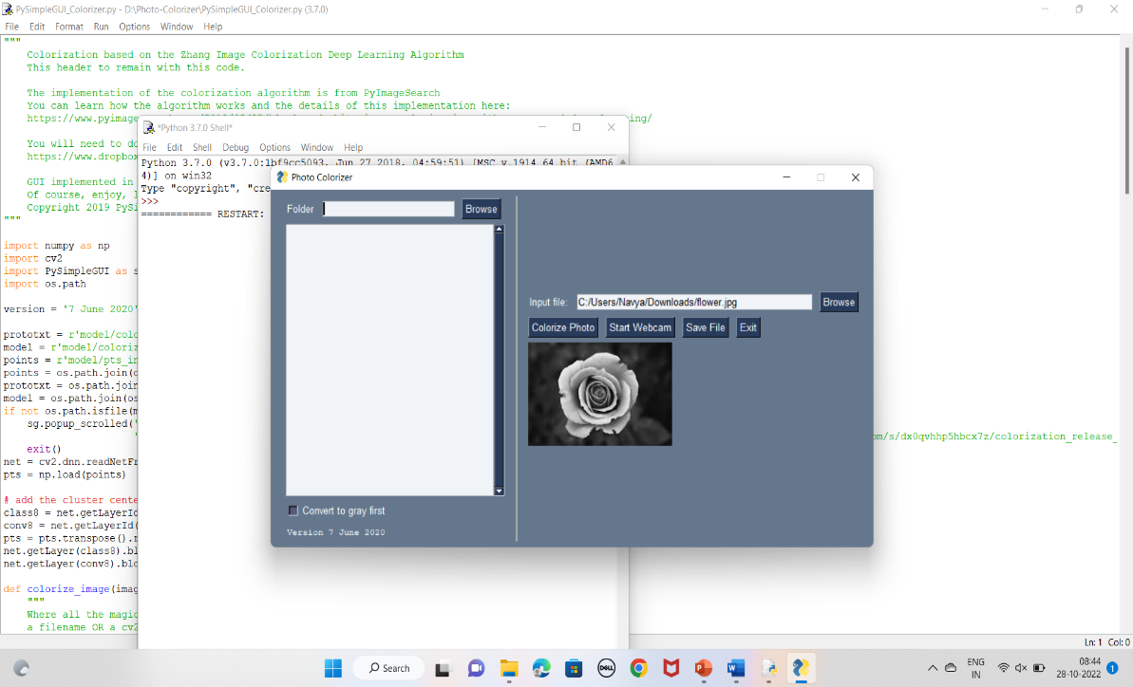

Figure 5.9 – Input Image

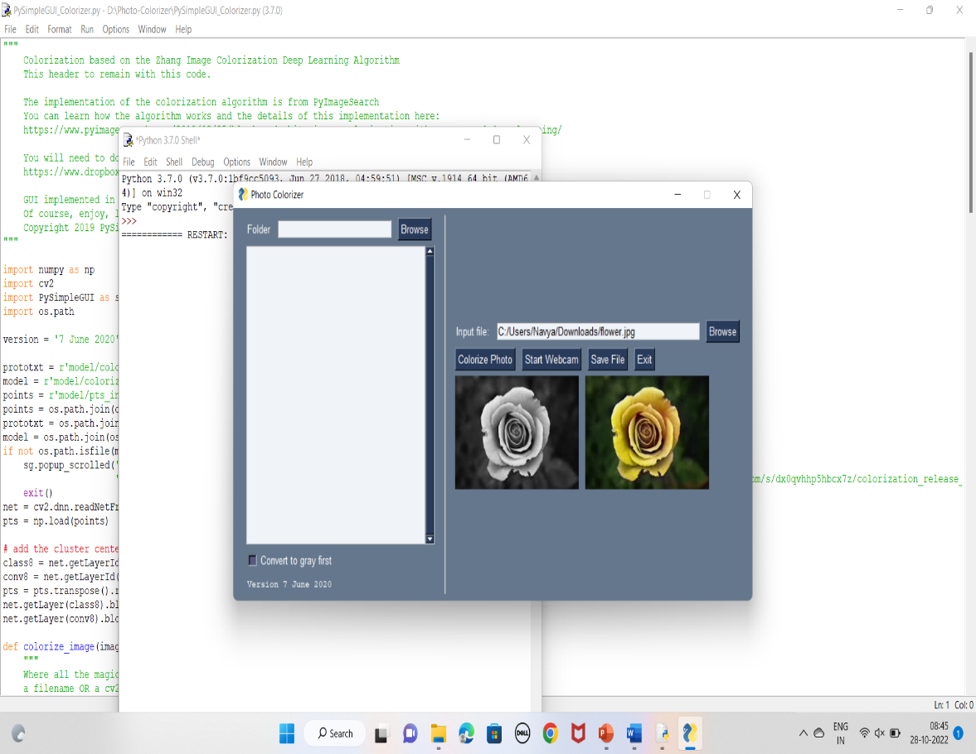

Figure 5.10 – Output Image



# CHAPTER 6

## CONCLUSION AND FUTURE WORK



#### CONCLUSION:

The Model is able to identify the correct pattern or shades in which the color must be filled or we can say the model is able to separate out the portions which is needed to be colored to get the colorized image but is not able to predict the accurate color for that shade or portion all the time with respect to the ground truth image.

Here Results also reflects the actual requirement for CNN and other image colorization techniques. We showed examples of plausible-looking generated images. Our results indicate that the presented method can be used as a creativity tool to assist human artists in near future.



* 1. **FUTURE WORK:**

Since our project only involves in colourizing a photo in future:

* We would like to add an option of increasing the clarity of pictures i.e., improving the clarity of a black and white picture after colourizing it.
* Converting a colored image to black and white if needed.
* Using the same it can be implemented to colourize videos.

**REFERENCES**

[1] E. Reinhard, M. Ashikhmin, B. Gooch, and P. Shirley, “Color transfer between images,” IEEE Computer Graphics Applications, vol. 21, no. 5, pp. 34–41, 2001.

[2] S. Beigpour and J. van de Weijer, “Object recoloring based on intrinsic image estimation,” ICCV, 2010.

[3] F. Pitie, A. C. Kokaram, and R. Dahyot, “Automated colour grading using colour distribution transfer,” Comput Vis Image Underst, pp. 123– 137, 2007.

[4] H. Chang, O. Fried, Y. Liu, S. DiVerdi, and A. Finkelstein, “Palettebased photo recoloring,” ACM Transactions on Graphics (Proc. SIGGRAPH), vol. 34, no. 4, 2015.

[5] K. Simonyan and A. Zisserman, 2015. Very Deep Convolutional Networks for Large-Scale Image Recognition. International Conference on Learning Representations 2015 (arXiv:1409.1556v6).

[6] K. He, X. Zhang, S. Ren, and J. Sun, 2015. Delving Deep into Rectifiers: Surpassing Human-Level Performance on ImageNet Classification. IEEE International Conference on Computer Vision 2015, pp. 1026-1034.

[7] L. A. Gatys, A. S. Ecker, and M. Bethge, 2015. A Neural Algorithm of Artistic Style. arXiv:1508.06576v2.

[8] A. Radford, L. Metz, and S. Chintala, 2016. Unsupervised Representation Learning with Deep Convolutional Generative Adversarial Networks. Under review for International Conference on Learning Representations 2016 (arXiv:1511.06434v2).

[9] J. Johnson, 2015. Torch implementation of neural style algorithm. https://github.com/jcjohnson/neural-style (last accessed on February 3, 2016).